Directions for using this template are contained within the template. Please read everything before deleting anything. **DELETE THIS BOX BEFORE PRINTING.**

Insert your title here using mixed case

Thesis

Presented in Partial Fulfillment of the Requirements for the Degree Master of Science the Graduate School of The Ohio State University

By

Sandeep Kumar Sulake

Graduate Program in Mechanical Engineering

The Ohio State University

2023

Thesis Committee

Qadeer Ahmed, Advisor

Lisa Fiorentini

Copyrighted by

Sandeep Kumar Sulake

2023

# Abstract

Begin Typing Here

The abstract is a required part of your document. The abstract begins on page ‘ii’ which is the first page number to appear in the document. The abstract is the first item to appear in the Table of Contents. The abstract is double spaced just as the document itself is double spaced.

**DELETE THIS BOX BEFORE PRINTING.**

# Dedication

Begin Typing Here

This is the (optional) Dedication page. If your document contains a dedication it replaces the text above (Begin Typing Here) and is paginated in sequence following the abstract.

**DELETE THIS INSTRUCTIONAL TEXT BOX BEFORE PRINTING**

**DELETE THIS WHOLE PAGE IF YOU ARE NOT INCLUDING A DEDICATION IN YOUR DOCUMENT**

# Acknowledgments

Begin Typing Here

This is the (optional) acknowledgments page. Acknowledgments must be written in complete sentences and double spaced.

**DELETE THIS INSTRUCTIONAL TEXT BOX BEFORE PRINTING**

**DELETE THIS WHOLE PAGE IF YOU ARE NOT INCLUDING ACKNOWLEDGMENTS IN YOUR DOCUMENT**

# Vita

Begin Typing Here

This is not a full CV.

This vita is broken down into three sections: Personal Information (including previous education and work experience); **DELETE THIS BOX BEFORE PRINTING**

Publications

Use standard citation format. List only those items actually published in a book or a journal. If you have no publication delete the Publications heading. **DELETE THIS BOX BEFORE PRINTING**

Fields of Study

Major Field:

The Major Field must match the official name of your graduate program as listed on the title pg. **DELETE THIS BOX BEFORE PRINTING**

Table of Contents

Abstract ii

Dedication iii

Acknowledgments iv

Vita v

List of Tables viii

List of Figures ix

Chapter 1. Introduction 1

Software Architecture and Subsystems in Autonomous Vehicles: 4

AutoDrive Challenge II 7

Thesis Overview 8

Chapter 2. Background and Literature Review 9

Decision making and motion planning in Autonomous vehicles. 9

Sequential Decision Making and Planning 10

Behavior-Aware Motion Planning 19

End-to-End Approach 19

Highway Lane Changing in Autonomous vehicles. 19

Lane Changing Approaches 20

Road risk in the presence of inclement weather conditions 23

Vehicle Weight Classes and Categories on highways 28

Artificial Potential Fields (APF) for Path Planning 29

APF Analogy: 30

APF Drawbacks: 32

FSM vs APF for Planning in Highway Environment 33

Chapter 3. Rule Based Highway Lane Changing for Autonomous Vehicles. 35

Lane change problem formulation 35

Static Obstacle Lane Change 35

Dynamic Obstacle Lane Change 35

Lane Change Trajectory Generation 36

Chapter 4. Improved Artificial Potential Field Approach for Highway Lane Changes 38

Artificial Potential Fields Methodology 38

Improved APF for lane changing in autonomous vehicles in the presence of low friction surfaces and different vehicle categories 38

Design requirements 38

Potential Field Functions 39

Gradient Descent for Path Planning 55

APF tuning process for path planning 57

Vehicle Dynamics and Control 59

Overall architecture 59

Results and Discussion 61

Chapter 5. Verification and Validation 67

Overview 67

Model in loop V&V 67

Hardware in loop V&V 68

Bibliography 69

# List of Tables

Table 1 A sample continued table 2

By using Word’s “Insert Caption….” Feature you can build your List of Tables (this page) and List of Figures (the following page). The label and number, the caption, and page number appear in columns 1, 2, and 3 respectively. You can update all fields prior to submitting your document by selecting the table, right click the text, and select “Update Field.”

**DELETE THIS INSTRUCTIONAL TEXT BOX BEFORE PRINTING**

**DELETE THIS WHOLE PAGE IF YOU DO NOT HAVE TABLES IN YOUR DOCUMENT**

# List of Figures

Figure 1 Location of "Breaks' on the Page Layout Tab 1

Figure 2. A continued figure. Part A Bar Graph; Part B. Line Graph; Part C Pie Chart 5

Figure 3 Sample Landscaped Page 18

By using Word’s “Insert Caption….” Feature you can build your List of Figures (this page) and List of Tables (the previous page). The label and number, the caption, and page number appear in columns 1, 2, and 3 respectively. You can update all fields prior to submitting your document by selecting the table, right click the text, and select “Update Field.”

**DELETE THIS INSTRUCTIONAL TEXT BOX BEFORE PRINTING**

**DELETE THIS WHOLE PAGE IF YOU DO NOT HAVE FIGURES IN YOUR DOCUMENT**

# Chapter 1. Introduction

Autonomous vehicles, also known as self-driving cars, have been in development for many years. The first autonomous vehicles were developed in the 1980s and 1990s, but they were very basic and not capable of driving on public roads. In the early 2000s, more advanced autonomous vehicles began to be developed, and they were able to navigate simple roads and highways under certain conditions.

Autonomous vehicles are being developed and tested for a variety of applications, including personal transportation, public transportation, and logistics. There is significant interest in using autonomous vehicles in these areas because they have the potential to improve safety, reduce costs, and increase efficiency.

Delays in traffic and congestion results in increased travel time and hence impacts the commute and economy in a negative manner. Automated platooning where vehicles drive in a platoon form with desired time gaps in between vehicles is a potential solution to these problems [1]. Highest level of autonomy in driving can greatly improve the human reaction time which in turn can increase the road capacity and improve the energy consumption of vehicles.

Autonomous vehicles could also be used in public transportation systems, such as buses or shuttles, allowing for more reliable and efficient service. In the logistics industry, autonomous vehicles could be used to transport goods between warehouses, distribution centers, and other locations, potentially reducing the need for human drivers and improving delivery times.

The interest in research and applications of autonomous vehicles in both the academic and commercial industry has grown rapidly because of the many promising benefits for society [2]. Autonomous vehicles domain is an interdisciplinary field which brings together a lot of research fields like robotics, computer science, electronics, and mechanical engineering. Environment perception, localization and mapping, path planning, decision making, motion planning and control are some of the important topics to be researched [3]. Software and functional architecture are driving factors to help build safe autonomous vehicles.

Many car manufacturers, tech companies, and startups are working on developing autonomous vehicles that can drive in a wide range of conditions and environments. These vehicles use a variety of sensors, such as lidar, radar, and cameras, to gather data about their surroundings and make decisions about how to navigate the road. They also use complex algorithms and machine learning techniques to analyze the data and make decisions about how to safely operate the vehicle. Some of these vehicles are fully autonomous, meaning they do not require a human driver at all, while others are semi-autonomous, meaning they still require a human driver to take control under certain circumstances. However, the state-of-the-art hardware and software technology used by these companies is hard to determine since these tech companies do not publicly disclose any information. While autonomous vehicles are not yet widely available to the public, it is expected that they will become more common in the coming years as the technology continues to advance. It is expected that the autonomous vehicles will be an efficient way of transportation by 2040 [4].

SAE levels of automation refer to a system of classification for self-driving cars developed by the Society of Automotive Engineers (SAE). There are six levels in total, ranging from level 0 to level 5, with each level representing a different degree of automation [5].

1. Level 0: No Automation - The driver always has full control of the vehicle, and there is no automation present.
2. Level 1: Driver Assistance - The vehicle has certain driver assistance features, such as adaptive cruise control or lane departure warning, but the driver is still responsible for most aspects of driving.
3. Level 2: Partial Automation - The vehicle has both acceleration and steering control and can assist the driver in certain situations such as highway driving, but the driver is still responsible for monitoring the environment and taking over if necessary.
4. Level 3: Conditional Automation - The vehicle can handle most driving situations, but the driver must be ready to take over if the system encounters a situation it cannot handle.
5. Level 4: High Automation - The vehicle can handle almost all driving situations, and the driver may not need to be present or always paying attention.
6. Level 5: Full Automation - The vehicle can handle all driving situations and the driver is not required to be present or pay attention to the road at any time.

This system has become the industry standard and is shown in the figure below.

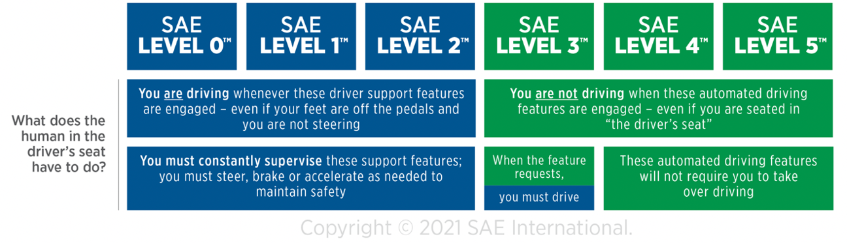

## Software Architecture and Subsystems in Autonomous Vehicles:

The software architecture of an autonomous vehicle is the overall design and structure of the software systems that enable the vehicle to sense its environment, make decisions, and control its movements. The software architecture of an autonomous vehicle typically consists of multiple layers or modules, each of which is responsible for a specific aspect of the vehicle's operation. Mainly, the modules include Perception, Localization, Decision Making and Control.

At the highest level, Perception and localization are two important capabilities for autonomous vehicles, as they allow the vehicle to sense its environment and determine its position and orientation. A perception system is responsible for interpreting the data gathered by the vehicle's sensors and creating a model of the vehicle's surroundings. These systems typically use a combination of sensors, such as cameras, LiDAR, and radar, to collect data about the vehicle's surroundings [6]. The data is then processed by software algorithms to create a detailed 3D map of the environment, which the vehicle can use to navigate and avoid obstacles. An example of a surrounding environment visualized with a specific set of sensors is shown below.

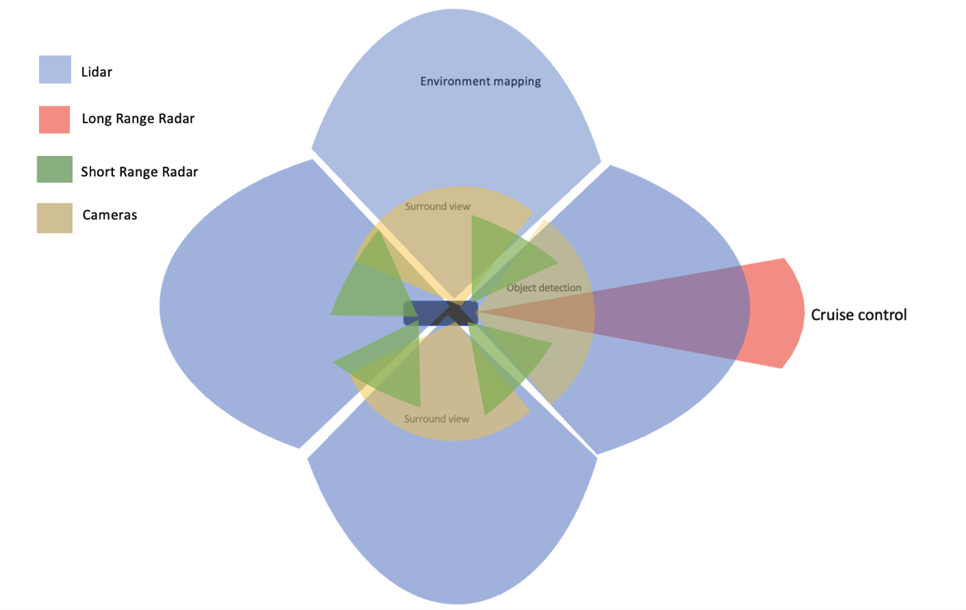

One important challenge in designing perception and sensing systems for autonomous vehicles is ensuring that they are accurate, reliable, and able to operate in a wide range of environmental conditions [7]. For example, sensors may be affected by rain, fog, or other weather conditions, which can reduce their effectiveness. Radar and ultrasonic sensors are widely used in this context since they use electromagnetic and ultrasonic waves. Additionally, the software algorithms used to process sensor data must be able to handle the large amounts of data generated by multiple sensors and make quick decisions based on that data [8].

Localization refers to the process of determining the position and orientation of the vehicle in its environment. This is typically done using a combination of techniques, such as GPS, LiDAR, visual localization, and inertial measurement unit (IMU) localization.

Perception and localization are closely related, as the vehicle's perception of its surroundings is used to inform its localization. For example, if an autonomous vehicle uses visual localization to determine its position, it will need to be able to identify features in its environment, such as landmarks or road signs, to match them to a pre-built map of the area. Similarly, if the vehicle uses LiDAR localization, it will need to be able to detect and measure the distance to objects in its environment to create a map of the surroundings.

Next is the decision-making system that is responsible for determining the appropriate actions for the vehicle to take based on its current state and its goals. The decision-making system uses various algorithms to analyze the data from the perception system and make decisions about how to operate the vehicle safely and effectively.

At the lowest level, the software architecture of an autonomous vehicle typically includes a control system that is responsible for managing the vehicle's physical systems, such as the steering, braking, and acceleration. The control system receives input from the higher-level planning modules, and it sends commands to the vehicle's actuators to control the vehicle's movements.

Finally, the software architecture of an autonomous vehicle typically includes a communication system that is responsible for transmitting and receiving data to and from other systems, such as the vehicle's sensors, actuators, and external systems, such as traffic lights and other vehicles. The communication system helps to coordinate the operation of the different components of the vehicle and ensure that the vehicle is able to interact with its environment in a safe and efficient manner. As the technology continues to advance, it is expected that the software architectures of autonomous vehicles will become increasingly sophisticated and capable of handling a wide range of driving scenarios.

## AutoDrive Challenge II

The challenge aims to have 10 university teams develop and demonstrate an autonomous vehicle (AV) that can navigate urban driving courses as described by SAE Standard (J3016™) Level 4 automation.

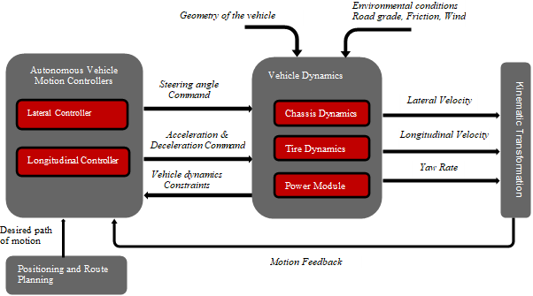

More about the challenge and the targets.

## Thesis Overview

Brief description of all the thesis contents.

# Chapter 2. Background and Literature Review

## Decision making and motion planning in Autonomous vehicles.

Decision making in autonomous vehicles is a complex and critical aspect of their operation. Autonomous vehicles rely on a range of sensors and algorithms to analyze data about their surroundings, identify potential hazards, and make decisions about how to navigate through their environment safely and efficiently. One of the biggest challenges in decision making for autonomous vehicles is dealing with the unpredictability of the real world. Autonomous vehicles need to be able to handle unexpected events, such as sudden changes in traffic or road conditions, and make decisions quickly and accurately in response. Therefore, they need approaches that can adapt to unpredictable scenarios and make quick and sound judgments, just like humans. To attain such a level of dependability, these vehicles rely on precise perception systems. However, the latest computer vision systems are still not accurate enough to facilitate reliable autonomous navigation as they cannot yet meet the acceptable error rates. The goal of developing fully functional self-driving vehicles is a daunting task that necessitates the resolution of numerous issues pertaining to technical, legal, and social aspects [9]. The Defense Advanced Research Projects Agency (DARPA) has been a major driving force behind the push for research in autonomous vehicles. DARPA is the research and development arm of the US Department of Defense, and it has been working on a range of projects related to self-driving technology for many years [10, 11]. The techniques used for self-driving vehicles in these projects were constrained to environments with relatively slower speeds and could only accommodate a limited number of moving obstacles. Although significant advancements have been made in the past decade, recent developments in self-driving technology still reveal limitations in terms of the complexity of the environment and/or the speed of movement [12, 13].

In general, decision-making, and motion planning can be categorized into three distinct approaches: sequential planning, behavior aware planning and end-to-end approaches.

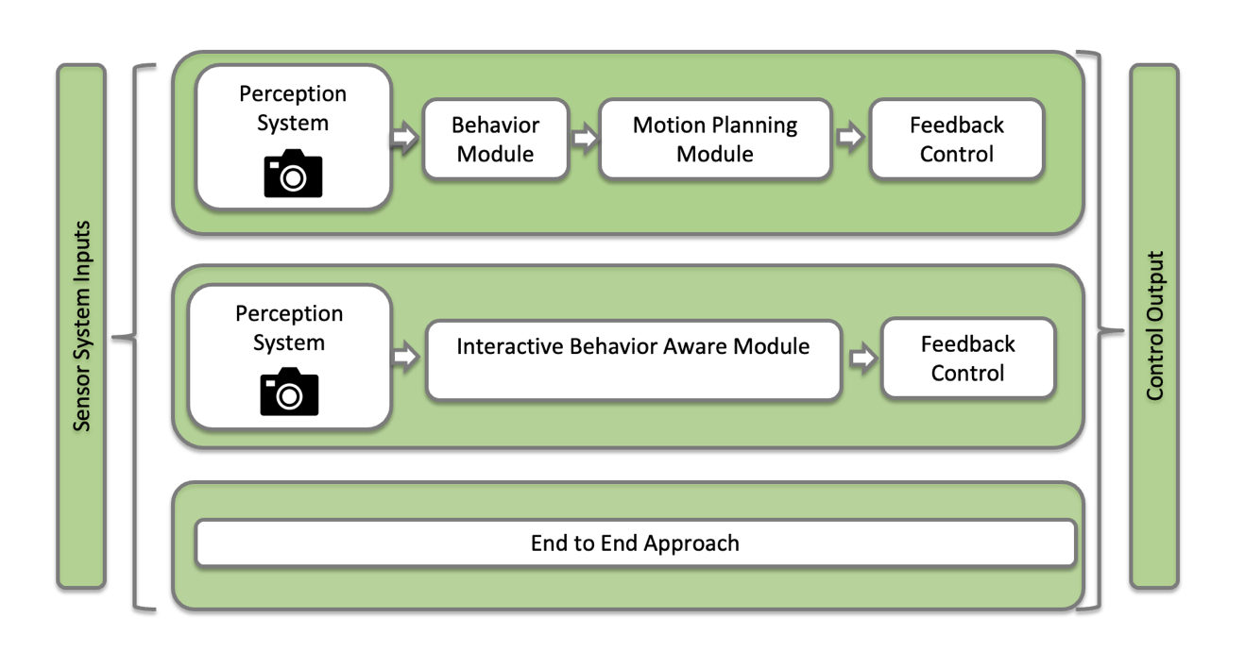

### Sequential Decision Making and Planning

Sequential decision making and planning refer to the process of an autonomous vehicle making a series of decisions to achieve a particular goal. This process involves selecting a sequence of actions that will allow the vehicle to navigate safely and efficiently from one location to another, while avoiding obstacles and following traffic rules.

The sequential decision-making system can be divided hierarchically into four levels. The topmost level involves planning a route through the road network. A behavioral layer follows this, determining the local driving task necessary for the car to move closer to its destination and abide by traffic regulations. Next, a motion planning module selects a

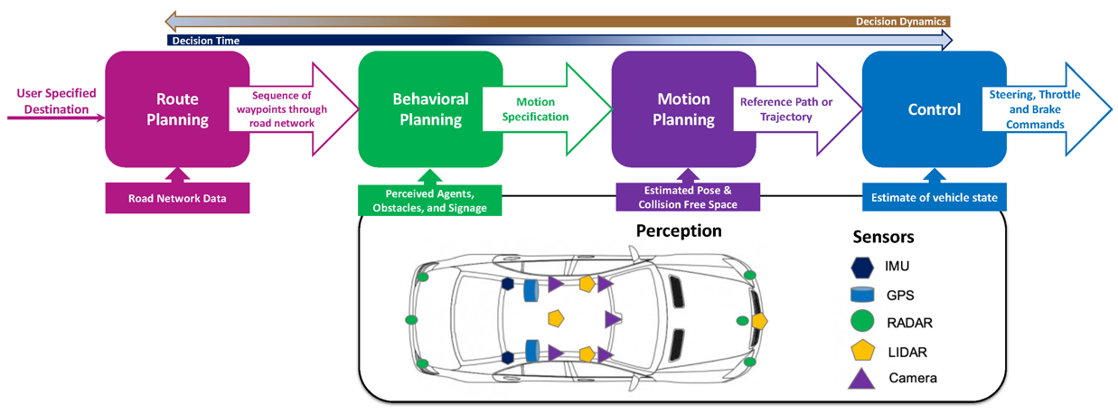continuous path that allows the car to fulfill its local navigational objective. Finally, the control system reacts to any discrepancies in the implementation of the planned motion and makes any necessary corrections.

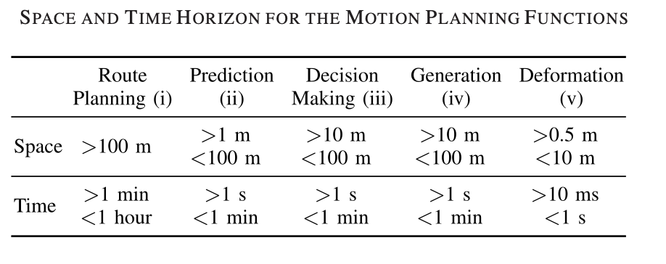

*Route Planning:*

The route planning module computes an optimal path from its current location to the desired destination through the road network. To achieve this, the road network can be represented as a directed graph where the edge weights represent the cost of traversing a particular road segment. The task of selecting a minimum-cost path on the graph can then be posed to determine the optimal route for the vehicle to take. But, shortest path algorithms like Dijkstra or A* [14] would be infeasible to apply to road networks which can have millions of edges. Some of the route planning algorithms that are commonly used in autonomous vehicles:

1. A* Algorithm: The A* algorithm is a widely used algorithm in autonomous vehicles. It is a heuristic search algorithm that finds the shortest path between two points. The A* algorithm uses a heuristic function to guide the search towards the goal.
2. D* Algorithm: The D* algorithm is a real-time planning algorithm used in autonomous vehicles. It updates the route in real-time as the vehicle moves through the environment, considering changes in the environment such as roadblocks, traffic, and accidents.
3. Probabilistic Roadmaps (PRM): The PRM algorithm is a sampling-based algorithm that constructs a roadmap of the environment. It then searches this roadmap to find the optimal path to the destination [15].
4. Rapidly Exploring Random Trees (RRT): The RRT algorithm is another sampling-based algorithm used in autonomous vehicles. It constructs a tree-like structure that explores the environment in a randomized manner and finds the shortest path to the destination [16].
5. Artificial potential fields (APF): APF can be used in route planning for autonomous vehicles. The algorithm is based on the concept of potential energy from physics. In this approach, the environment is represented as a potential field, where the goal location is assigned the minimum potential energy and obstacles are assigned high potential energies. The vehicle then navigates through the environment by following the gradient of the potential field towards the goal location while avoiding obstacles [17].

These algorithms are often used in combination to provide robust and efficient route planning for autonomous vehicles. The choice of algorithm depends on the specific requirements of the application and the environment in which the vehicle is operating.

*Behavior Module:*

Once a route has been determined, the autonomous vehicle needs to navigate the chosen path and follow driving conventions and road regulations while interacting with other drivers. The behavioral layer is accountable for selecting the suitable driving behavior at any given moment by taking into consideration factors such as the behavior of other drivers, road conditions, and signals from the infrastructure, given a sequence of road segments that define the selected route. For example, when an autonomous vehicle encounters a traffic light, it must make a sequence of decisions to determine whether to stop or proceed through the intersection. The behavior module must decide whether to stop or proceed based on the vehicle's current speed, the distance to the intersection, and the duration of the traffic signal.

Finite state machines (FSMs) are a popular approach for behavior modeling in autonomous vehicles. They are the mathematical models that describe the behavior of a system in terms of a finite set of states and the transitions between them. FSMs can be used to model the behavior of the vehicle in different situations [18]. Each state in the FSM represents a particular behavior or action that the vehicle can take, and the transitions between the states represent the conditions under which the vehicle should switch from one behavior to another. The transitions are triggered by inputs from the vehicle's sensors.

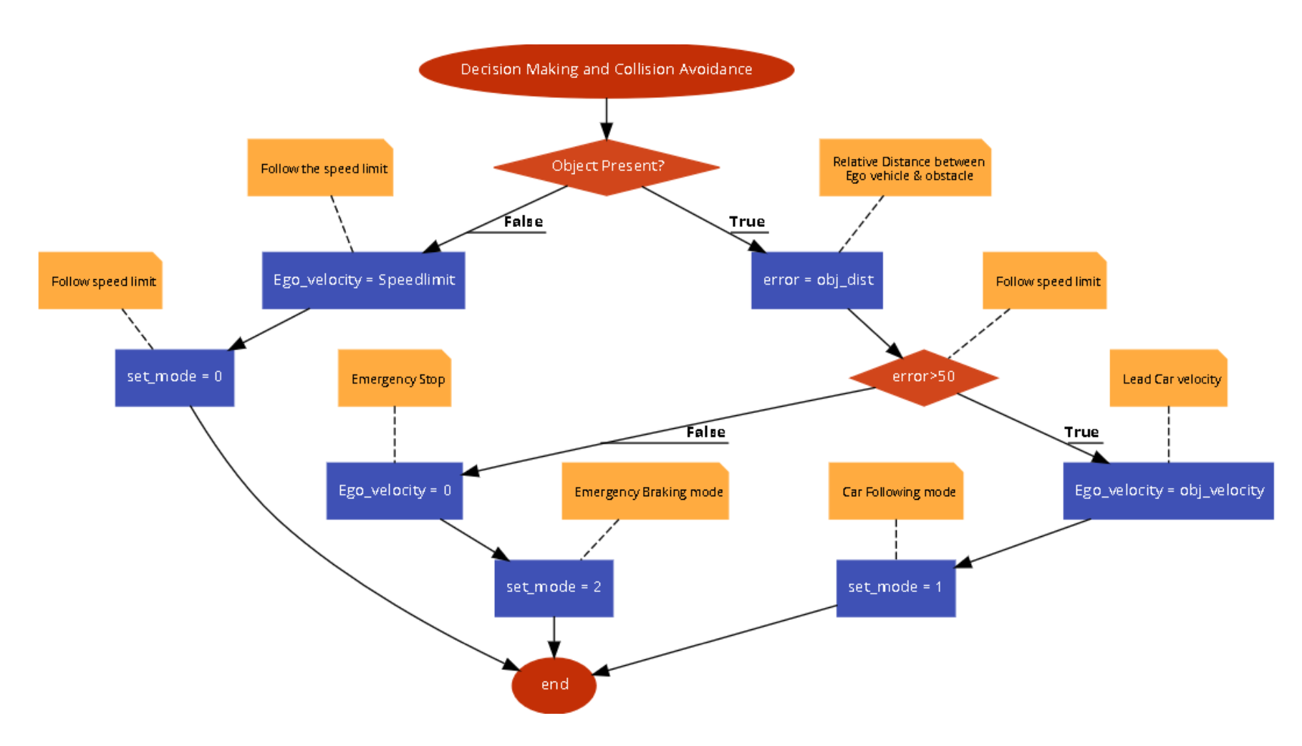

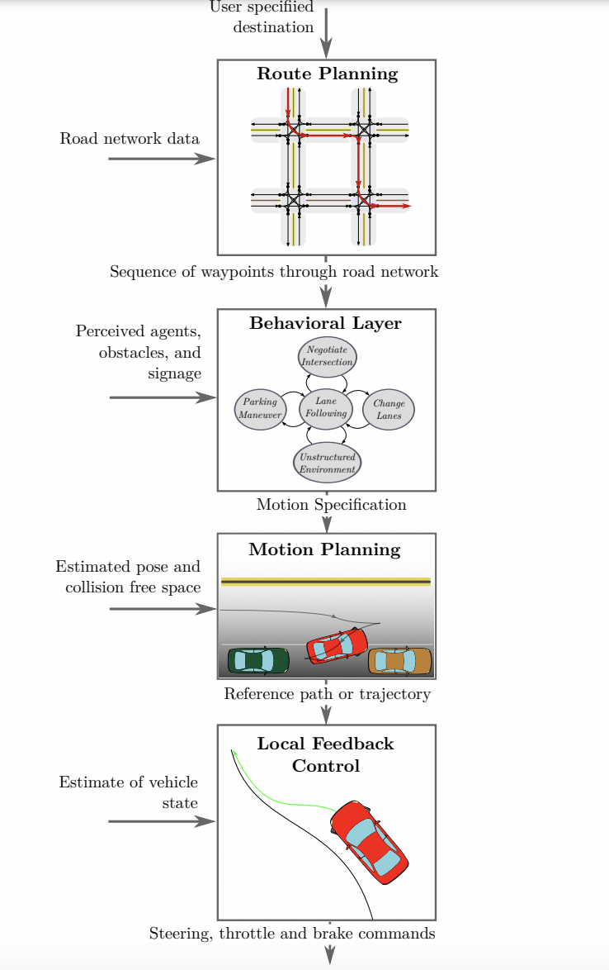

In actual driving scenarios, particularly in urban areas, uncertainty regarding the intentions of other drivers is a common occurrence. The issue of predicting intentions and estimating the future movements of other vehicles, bicycles, and pedestrians has also been the subject of research. Gaussian mixture [19] and Gaussian process regression [20] models are some of the machine learning techniques that are used for intention prediction of traffic participants. Probabilistic planning methods, such as Markov Decision Processes, are often utilized in the decision-making process at the behavioral layer to account for these uncertain behaviors of the traffic participants. Several studies also utilize the partially observable Markov decision process (POMDP) framework to explicitly model undisclosed driving scenarios and the intentions of pedestrians [21, 22, 23].

*Motion Planning*

After the decision-making module of an autonomous vehicle determines the desired trajectory or route to follow, the motion planning module takes over and generates a safe and feasible motion plan to execute the desired trajectory. The motion planning module considers various factors such as the current state of the vehicle, the surrounding environment, traffic rules, and constraints such as speed limits, vehicle dynamics, and other obstacles. It then generates a detailed plan for the vehicle's motion, including the vehicle's speed, acceleration, and steering angles.

The motion planning task for an autonomous vehicle is equivalent to solving the motion planning problem that is commonly discussed in robotics literature. Finding exact solutions to this problem is usually computationally infeasible, so numerical approximation methods are commonly utilized. Some of the approaches to motion planning system in autonomous vehicles are as follows:

1. Sampling-based methods: These methods generate a set of candidate paths and select the best one based on some cost function. Popular sampling-based methods include Rapidly exploring Random Trees (RRTs) and Probabilistic Roadmaps (PRMs) [24, 25]
2. Optimization-based methods: These methods frame motion planning as an optimization problem that seeks to minimize a cost function while satisfying constraints [26].
3. Learning-based methods: These methods use machine learning techniques to learn motion planning policies from data. Reinforcement learning is one example of a learning-based approach that has been used for motion planning in autonomous vehicles [27].

*Vehicle Control*

After motion planning, the vehicle control system is responsible for executing the planned trajectory by adjusting the vehicle's acceleration, steering, and braking inputs in real-time. The control system must ensure that the vehicle follows the planned path while satisfying safety constraints, such as maintaining a safe speed and avoiding obstacles or other vehicles. The importance of the vehicle control system lies in its ability to accurately track the planned trajectory, despite uncertainties in the vehicle's dynamics and the environment. The control system must also respond quickly to unexpected events, such as sudden changes in road conditions or the presence of pedestrians, to ensure safe and efficient operation of the vehicle. There are several types of control systems used in autonomous vehicles, each with its own strengths and limitations. Here are some examples:

1. Proportional-Integral-Derivative (PID) Control: This is a simple and widely used control system that adjusts the vehicle's control inputs based on the difference between the desired and actual state of the vehicle. PID control is effective for controlling simple tasks such as steering, braking, and throttle control.
2. Model Predictive Control (MPC): MPC is a popular control system for autonomous vehicles that uses a predictive model to optimize vehicle control inputs over a finite time horizon. MPC can handle nonlinearities and constraints, making it effective for complex tasks such as trajectory planning and obstacle avoidance.
3. Adaptive Control: Adaptive control adjusts the control system parameters based on changes in the vehicle's dynamics or environment, allowing the control system to adapt to changing conditions. Adaptive control is effective for handling uncertainties and variations in the vehicle and environment.
4. Fuzzy Logic Control: Fuzzy logic control uses linguistic rules and fuzzy sets to handle uncertainties in the system and environment. Fuzzy logic control is effective for handling complex and nonlinear systems and is commonly used in navigation and obstacle avoidance tasks.
5. Artificial Neural Networks (ANN) Control: ANN control uses artificial neural networks to learn control policies based on input data from the vehicle's sensors. ANN control can adapt to changing conditions and is effective for handling complex tasks such as vision-based navigation and decision making.

### Behavior-Aware Motion Planning

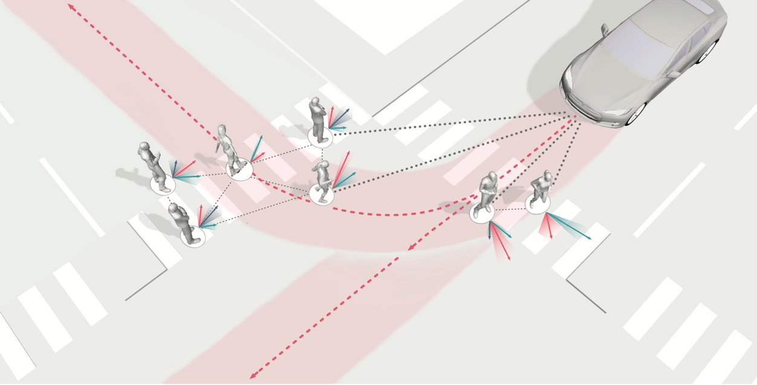Behavior-aware motion planning in autonomous vehicles involves designing algorithms and techniques that can make the vehicle navigate safely and efficiently through complex environments while considering the behavior of other road users. The goal is to enable the autonomous vehicle to make intelligent decisions based on its environment and the behavior of other agents in the scene.

The actions of other traffic participants in the future are influenced not only by their past actions and current states, but also by the potential actions of the host vehicle. Therefore, behavior predictions should consider the impact of the host vehicle's actions on the behavior of other participants in an interactive way. Additionally, the behavior and movements of other vehicles are probabilistic and depend on driving patterns and intentions, which vary from aggressive to conservative. Assumptions based on behavior models with fixed likelihoods are not practical in real-world situations. Also, effectively integrating intention predictions into the motion planning of the autonomous vehicle, while accounting for highly diverse and dynamic driving behavior patterns, is still an active area of research.

One popular approach to model behavior aware planning is to use reinforcement learning to train the autonomous vehicle to predict the behavior of other road users and adjust its own behavior accordingly [28]. Another approach is to use machine learning to learn a model of the environment and predict the behavior of other road users based on sensor data. For example, a neural network can be trained on data from sensors such as cameras and LiDAR and learn to predict the future trajectories of other vehicles, pedestrians, and cyclists. Based on these predictions, the autonomous vehicle can plan its own trajectory to avoid collisions and maximize efficiency.

### End-to-End Approaches

Contrary to traditional approaches, end-to-end planning in autonomous vehicles seeks to integrate all these subsystems into a single unified system. This approach allows the vehicle to make more informed and coordinated decisions, considering all the relevant information about the surrounding environment and the desired destination.

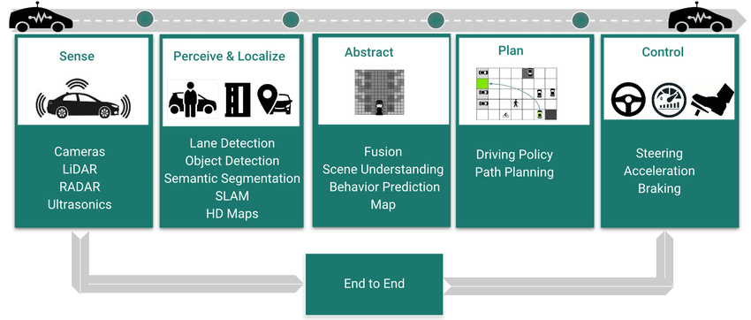

In end-to-end planning, decision-making is typically handled by a machine learning model that has been trained on a large dataset of real-world driving scenarios. An example of such a system is where a fully convolutional neural network (FCN) is used that can jointly learn to perform perception and path generation in the ground plane from real-world driving sequences. Driving paths are then generated by integrating various data sources such as lidar point clouds, GPS-IMU information, and Google navigation information [29]. End-to-end systems can be taken to the next level by learning the complete task of following a lane or road, without the need for manual decomposition into detecting road or lane markings, semantic abstraction, path planning, and control. Some pioneering research works demonstrated end-to-end driving by training a neural network to directly output steering angles based on camera images, with the goal of keeping the vehicle on the road [30, 31].

Due to the increased GPU-computing capabilities for efficient learning of convolutional neural networks, common networks have grown deeper and now contain a greater number of parameters, leading to improved performance in end-to-end driving since its inception in 1989. Researchers at NVIDIA trained deep convolutional neural networks to directly map raw images from a front-facing camera to steering commands, achieving the ability to navigate challenging scenarios such as driving on gravel roads, passing through roadwork, and driving in poorly lit environments at night [32].

## Highway Lane Changing in Autonomous vehicles.

### 

Highway driving is considered the most reachable environment for autonomous driving applications for several reasons:

1. Predictable environment: Highway driving is a relatively predictable environment compared to other driving scenarios. The roadways are well-defined, and traffic typically flows in the same direction. There are fewer pedestrians and obstacles on the road, and there are clear rules for merging and exiting.
2. Consistent speeds: Vehicles on the highway generally travel at consistent speeds, with few stops or changes in speed. This makes it easier for autonomous vehicles to maintain a safe and consistent speed and distance from other vehicles.
3. Limited maneuvers: Compared to city driving, highway driving requires fewer maneuvers, such as turning and navigating intersections. This reduces the complexity of the driving task and makes it easier for autonomous vehicles to operate.
4. Existing infrastructure: Highways are typically well-maintained and equipped with infrastructure such as lane markers, signs, and signals. This infrastructure can be leveraged by autonomous vehicles to navigate the roadway.
5. High demand: There is a high demand for autonomous driving on highways due to the long distances and frequent traffic congestion. This demand can drive innovation and investment in the technology.

Overall, the predictable environment, consistent speeds, limited maneuvers, existing infrastructure, and high demand make highway driving the most reachable environment for autonomous driving applications. As the technology continues to improve, it is expected that autonomous vehicles will eventually be able to operate in more complex driving scenarios, such as urban and suburban environments.

### Lane Changing Approaches

There are several key challenges that autonomous vehicles (AVs) must overcome to navigate on highways safely and effectively. Some of these include:

Lane Keeping and Lane Changing:

AVs must be able to accurately detect and stay within the lanes on the highway, as well as safely and smoothly change lanes when necessary.

Lane keeping and lane changing are important capabilities for autonomous vehicles (AVs) to have when driving on highways. These tasks can be challenging for AVs because they require the vehicle to accurately perceive and understand its environment, as well as make safe and smooth driving decisions. One of the key challenges in lane keeping is accurately detecting and tracking the lanes on the road. This is typically done using a combination of cameras, lidar, radar, and other sensors, which can detect the edges of the lanes and other road markings. The sensor data is then processed using computer vision algorithms that can identify the lanes and track their position over time.

Once the lanes have been detected and tracked, the AV can use control algorithms to keep the vehicle within the lanes. This typically involves using a combination of steering, braking, and acceleration commands to control the position and speed of the vehicle. The control algorithms should be robust enough to handle different road conditions and lane geometry, such as curved roads and merging lanes.

Lane changing is similarly challenging and requires the AV to have a precise understanding of its environment and the intentions of other vehicles on the road. The AV must detect and track the other vehicles and use this information to plan and execute safe lane changes. This typically involves assessing the speed, position, and trajectory of the other vehicles, and using this information to calculate safe gaps for lane changes. The AV must also consider the surrounding traffic and any potential hazards, such as construction or emergency vehicles.

To ensure safety, the decision-making and control algorithms for lane keeping and lane changing are typically tested extensively in simulation and on test tracks before being deployed on real roads.

In general, Lane keeping and lane changing are complex task for autonomous vehicles, it is important to note that many companies are testing their AVs on different geographical locations to adapt and enhance their systems to work optimally based on different weather conditions, and traffic flow.

1. Handling high-speed driving: AVs must be able to drive at high speeds safely and comfortably, which can be challenging due to the large forces involved. This requires the vehicle to have precise and responsive steering, braking, and acceleration capabilities.
2. Handling merging and merging traffic: AVs must be able to safely enter and exit highway on-ramps and off-ramps, as well as navigate through merging traffic. This requires the vehicle to have an accurate understanding of its environment and the intentions of other vehicles on the road.
3. Handling different weather and lighting conditions: AVs must be able to operate in a wide range of weather and lighting conditions, including rain, fog, snow, and darkness. This requires the vehicle to have robust perception capabilities that can handle occlusions and reflections caused by different weather and lighting conditions.
4. Handling emergency and unexpected events: AVs must be able to handle emergency and unexpected events, such as sudden braking safely and smoothly by other vehicles, lane closures, and construction zones. This requires the vehicle to have an accurate understanding of its environment and the ability to make rapid and safe decisions.
5. Handling traffic laws and regulations: AVs must be aware and follow all traffic laws and regulations. which can vary from state to state, country to country and region to region. They should also be designed to handle specific situations such as emergency vehicles, school buses and many more.

Overall, developing AVs that can safely and effectively navigate on highways requires a combination of advanced sensor technologies, sophisticated perception and decision-making algorithms, and rigorous testing and validation.

### Road risk in the presence of inclement weather conditions

Each year, snow and freezing rain make road conditions dangerous for drivers as the accumulation of snow and ice creates slippery surfaces that reduce traffic mobility and safety. To avoid accidents, drivers often reduce their speed by 30-40% on snowy or slushy pavement, resulting in up to a 50% increase in travel delays [29]. However, reducing speed does not necessarily improve safety as vehicle collisions during the winter usually increase by 3.1-4.7%, with almost 28% of all casualty collisions happening on roads covered with slush, snow, or ice [30]. Therefore, it is crucial for authorities to actively combat winter weather conditions by maintaining the roads effectively.

Countries that experience winter weather recognize the importance of combatting adverse road conditions by allocating significant capital towards winter maintenance operations (WRM) to improve mobility and public wellbeing. In the US, state governments allocate approximately 20% of their maintenance budget to WRM, with an annual expenditure of over $2.3 billion on snow and ice control operations [30]. As WRM can be costly, transportation agencies are constantly searching for cost-effective strategies to maximize their investment return [31]. One key element in creating such a strategy is having access to diverse road surface conditions (RSC) information. This information helps maintenance personnel to understand the state of the road network and develop an effective treatment strategy. However, before collecting RSC information, appropriate RSC measures must be selected by jurisdictions. Traffic speed recover time, Visual indicators and road friction levels are some of the methods for RSC [32]. Traffic speed recovery times are continuous measurements, but they do not consider road conditions during harsh weather events. Road friction is the most used and straightforward method among various approaches. It is defined as the resistance between the tires of vehicles and the road and provides continuous and objective measurements expressed as a coefficient of friction ranging from 0 to 1. Moreover, friction measurements can be utilized to evaluate road maintenance performance during and after a storm event. Due to its widespread use and intuitive nature, friction coefficient is used as one of the critical parameters for the lane change in presence of inclement weather conditions in this study. The road friction coefficient is affected by several factors such as the texture of tires, contaminants, and the type of pavement on the road. Besides, environmental conditions have been proven to have a significant impact on the road friction [33, 34, 35]. Road Weather Information Systems (RWIS) can provide real time weather data and other generic road conditions. We assume to have the friction coefficient data from the RWIS for highways.

Several elements, including but not limited to the texture of tires and pavement and the pollutants on the road surface, can influence the road friction [9]. Additionally, environmental conditions have been proven to have a significant impact on road friction [10–18], which can be evaluated using weather data from Road Weather Information Systems (RWIS) [19]. RWIS offers real-time meteorological, environmental, and generic road conditions information, making it one of the most crucial highway intelligent transportation systems (ITS) infrastructures. For the road risk identification in adverse weather conditions, three risk categories for friction coefficient have been assumed and are generally used in the existing literature. High risk category has the friction coefficients below 0.3, medium risk category has the friction coefficients between 0.3 and 0.5. Low risk category is above 0.5 [36].

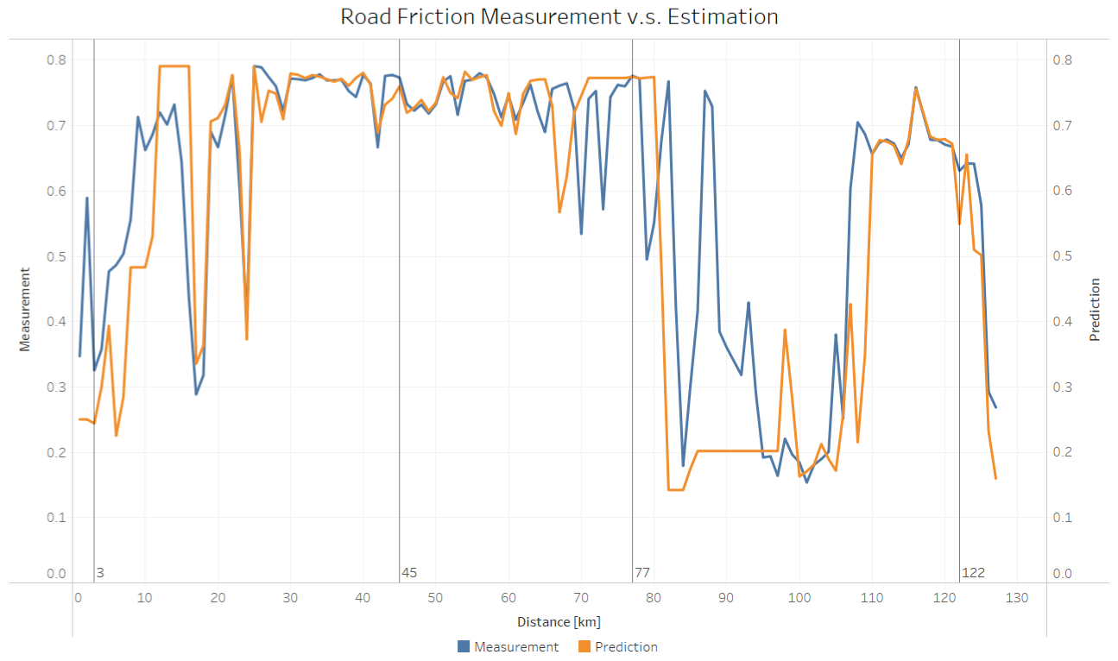

Lane changes for autonomous vehicles in challenging weather conditions, such as heavy rain, snow, or fog, can be a complex task. Autonomous vehicles rely on a variety of sensors, such as cameras and LIDAR, to detect and interpret the road and other vehicles. In challenging weather conditions, these sensors can be affected by reduced visibility, glare, and reflections.

To safely perform lane changes in challenging weather conditions, autonomous vehicles must have the following capabilities:

1. Weather-adaptive sensors: The vehicle's sensors must be able to detect and track objects in challenging weather conditions and be able to adjust their performance accordingly.
2. Weather-adaptive control systems: The vehicle's control systems, such as the steering and braking systems, must be able to respond quickly and accurately to the road conditions, adjusting the vehicle's trajectory and speed as necessary to maintain stability and avoid skidding.
3. Weather-adaptive software algorithms: The vehicle's software must be able to process sensor data and adjust the vehicle's behavior in real-time to ensure a safe journey. This includes adjusting the vehicle's speed, trajectory, and following distance based on the road conditions.

It's worth mentioning that the implementation of these capabilities is a challenging task, and some companies are still working to improve the system to work under all weather conditions.Top of Form Some of the critical parameters to analyze the lane change behavior in challenging weather conditions can be:

1. Traction control: Autonomous vehicles must have a reliable traction control system to maintain a stable and safe trajectory on slippery roads. This includes monitoring wheel slip and adjusting the engine's power output to prevent skidding.
2. Speed: The vehicle's speed must be adjusted based on the road conditions to ensure safe lane changing. On slippery roads, the vehicle should be driven at a lower speed to increase stability and reduce the risk of skidding.
3. Steering and braking: The vehicle's steering and braking systems must be able to respond quickly and accurately to the road conditions. This includes adjusting the steering angle and brake pressure to maintain control of the vehicle and avoid skidding.
4. Sensor performance: The vehicle's sensors, such as cameras and LIDAR, must be able to accurately detect and interpret the road and other vehicles in the presence of adverse weather conditions, such as heavy rain and fog.
5. Road information: The vehicle's software must have access to accurate and up-to-date information on the road conditions, such as the location of standing water or ice, to adjust its behavior and ensure a safe journey.
6. Vehicle dynamics: the vehicle's dynamics, such as the vehicle mass, center of gravity, and tire-road friction, must be taken into account when making lane changes on slippery roads.
7. Emergency braking: the vehicle must be able to apply emergency braking when it detects a potential collision or hazardous situation.

Overall, lane changing for autonomous vehicles in slippery road conditions requires a combination of advanced sensors, control systems, and software algorithms to safely navigate the vehicle in these challenging conditions.

### Vehicle Weight Classes and Categories on highways

1. Light duty vehicles: These are vehicles designed for personal use or light commercial use and are typically under 10,000 pounds gross vehicle weight rating (GVWR). Examples of light duty vehicles include passenger cars, SUVs, pickup trucks, and vans. Light duty vehicles are generally used for transportation of people and small loads and are not designed for heavy-duty work.
2. Medium duty vehicles: These are vehicles designed for commercial use and are typically between 10,000 and 26,000 pounds GVWR. Examples of medium duty vehicles include delivery trucks, tow trucks, and dump trucks. Medium duty vehicles are designed for heavier loads and more demanding work than light duty vehicles but are still smaller and more maneuverable than heavy duty vehicles.
3. Heavy duty vehicles: These are vehicles designed for heavy commercial use and are typically over 26,000 pounds GVWR. Examples of heavy-duty vehicles include tractor-trailers, construction vehicles, and buses. Heavy duty vehicles are designed for carrying heavy loads and performing demanding work, and often require specialized training and licensing to operate.

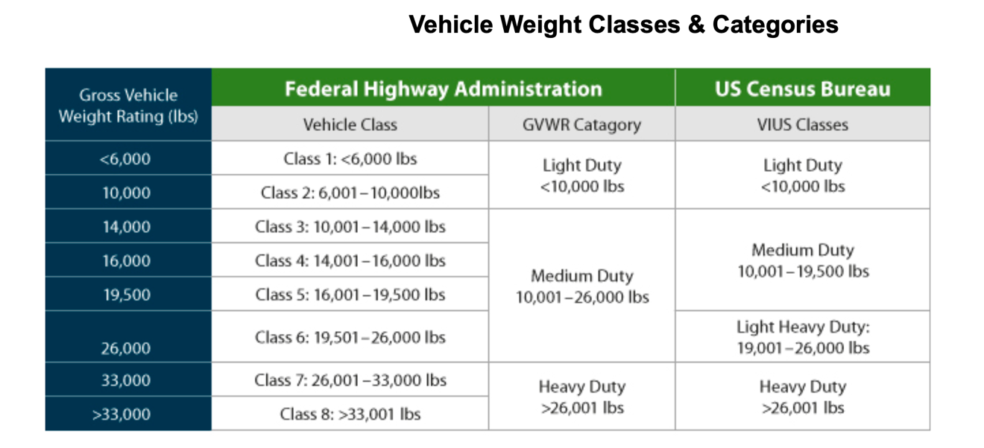

The distinction between light, medium, and heavy-duty vehicles is important for a number of reasons, including licensing and regulation, fuel efficiency standards, and safety requirements. Additionally, the different classes of vehicles have different capabilities and are designed for different types of work, so it's important to select the right type of vehicle for a given job to ensure safety and efficiency.

## Artificial Potential Fields (APF) for Path Planning

Artificial Potential Fields (APF) is a method used in robotics for motion planning and obstacle avoidance. It is based on the concept of creating a virtual potential field around the robot, which guides it towards the goal while avoiding obstacles. The method involves defining a potential function that represents the forces acting on the robot in its environment, including attractive forces towards the goal and repulsive forces away from obstacles. The resulting force field is then used to guide the robot's motion.

The basic concept of APF is to define an attractive potential field around the goal location, such that the robot moves towards it. The potential field is represented as a scalar function, which decreases as the robot gets closer to the goal. At the same time, a repulsive potential field is defined around obstacles, such that the robot moves away from them. The repulsive potential field is also represented as a scalar function, which increases as the robot gets closer to the obstacles. The resulting force field is the superposition of these two potential fields, which generates a vector field that guides the robot towards the goal while avoiding obstacles.

The attractive potential is typically represented by a Gaussian function centered on the goal location, while the repulsive potential is represented by an inverse distance function, which increases as the robot approaches the obstacle. The resulting potential function is then used to calculate the gradient of the field, which provides the direction of motion for the robot.

One of the advantages of the APF method is that it is computationally efficient and can handle complex environments with multiple obstacles. However, it can suffer from local minima where the robot gets stuck in a suboptimal position due to the potential field. Various modifications and enhancements have been proposed to address this issue, such as adaptive and hybrid potential fields.

### APF Analogy:

An analogy for the Artificial Potential Fields (APF) method is the way a ball moves on a surface with hills and valleys. Imagine a ball rolling on a surface with hills and valleys. The goal is to move the ball from its initial position to a target position while avoiding obstacles along the way.

The surface can be thought of as a potential field, where the hills represent obstacles, and the valleys represent the goal. The ball represents the robot or vehicle, which moves under the influence of the forces acting on it. In this analogy, the force acting on the ball is equivalent to the gradient of the potential field.

The APF method works by defining an attractive potential field around the target position, which pulls the ball towards the goal. At the same time, a repulsive potential field is defined around the obstacles, which pushes the ball away from them. The resulting force acting on the ball is the sum of these two potential fields, which guides the ball towards the goal while avoiding obstacles.

The strength of the repulsive potential field depends on the distance between the ball and the obstacles. When the ball is close to an obstacle, the repulsive force is strong, which pushes the ball away from the obstacle. As the ball moves away from the obstacle, the repulsive force decreases, and the ball moves towards the target position.

Similarly, in APF method, the strength of the repulsive potential field depends on the distance between the robot or vehicle and the obstacles. The attractive potential field is centered on the target position, and the repulsive potential field is centered on the obstacles. The resulting force acting on the robot or vehicle is used to guide it towards the goal while avoiding obstacles.

### APF Drawbacks:

While Artificial Potential Fields (APF) is a popular method for motion planning and obstacle avoidance in autonomous vehicles, it has some drawbacks that need to be considered. Some of the drawbacks of APF for autonomous vehicles are:

1. Local minima: One of the main drawbacks of APF is that it can suffer from local minima, where the robot or vehicle can get stuck in a suboptimal position due to the potential field. This happens when the robot or vehicle gets trapped between repulsive forces from multiple obstacles, which makes it difficult to find a clear path to the goal position. Various modifications and enhancements, such as adaptive and hybrid potential fields, have been proposed to address this issue.
2. Sensitivity to potential function parameters: The performance of APF is sensitive to the choice of parameters for the potential function. If the parameters are not chosen carefully, the robot or vehicle may collide with obstacles or take longer routes to reach the goal position.
3. Limited ability to handle complex environments: APF can struggle in highly complex environments with multiple obstacles, as the potential function may become too complex to be effectively used for motion planning. In such cases, other methods such as probabilistic algorithms or machine learning approaches may be more suitable.

## FSM vs APF for Planning in Highway Environment

Artificial potential fields (APF) can help to model environment uncertainties in decision making more effectively than finite state machines. Here are some reasons why:

1. Reactive: Unlike finite state machines, which are pre-programmed with a fixed set of states and actions, APF is a reactive approach that can adapt to changes in the environment in real-time. This makes it more effective at handling uncertainties and unforeseen events.
2. Continuous Space: APF operates in continuous space, allowing it to represent a wider range of environment uncertainties than finite state machines. This is because it can consider the precise location and movement of obstacles, rather than simply classifying them into discrete categories.
3. Flexibility: APF is highly flexible and can be applied to a wide range of tasks, from obstacle avoidance to path planning. This flexibility makes it easier to adapt to different types of environment uncertainties and handle a wider range of scenarios.
4. Learning: APF can be combined with machine learning algorithms to enable the robot to learn from its environment and improve its decision-making capabilities over time. This makes it easier to adapt to new and changing environments and to handle a wider range of uncertainties.

In summary, artificial potential fields can help to model environment uncertainties in decision making more effectively than finite state machines by providing a reactive, flexible, and continuous approach that can adapt to changes in the environment in real-time.

# Chapter 3. Rule Based Highway Lane Changing for Autonomous Vehicles.

## Lane change problem formulation

### Static Obstacle Lane Change

### Dynamic Obstacle Lane Change

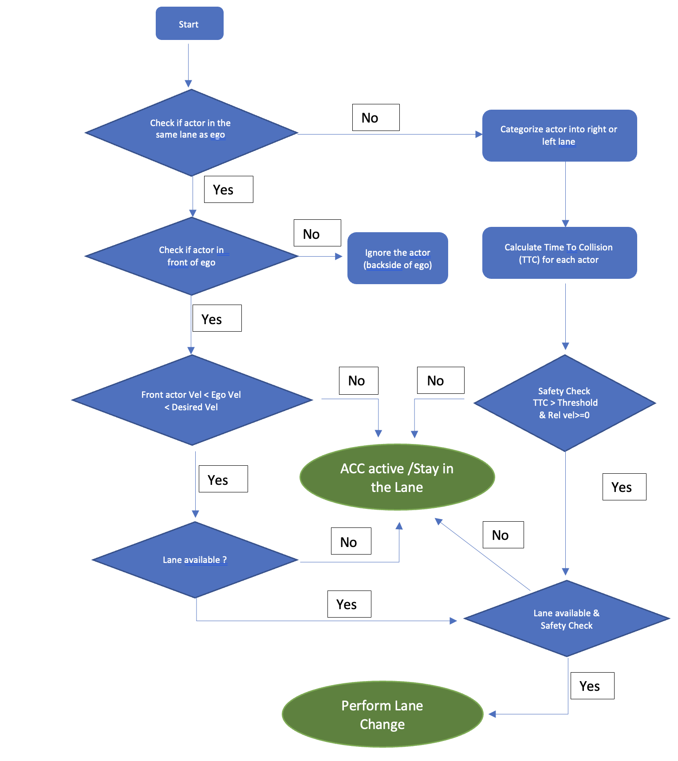

### Lane Change Trajectory Generation

# Chapter 4. Improved Artificial Potential Field Approach for Highway Lane Changes

## Artificial Potential Fields Methodology

## Improved APF for lane changing in autonomous vehicles in the presence of low friction surfaces and different vehicle categories

APF can be used in autonomous vehicles for lane change maneuvers. Lane change maneuvers involve detecting an opening in the adjacent lane and then changing the lane while avoiding collisions with other vehicles. The APF method can help in generating a collision-free path for the lane change maneuver by creating a virtual potential field around the vehicle.

To implement APF for lane change maneuvers, the attractive potential field is towards the goal position. and the repulsive potential fields are centered around the other vehicles. The repulsive potential fields should be strong enough to keep the vehicle away from the other vehicles, but not too strong that it becomes difficult to find a path through the potential field.

### Design requirements

Design requirements for the application of Artificial Potential Fields (APF) in lane changing for autonomous vehicles include the following:

1. Object detection: The first requirement is to have a reliable object detection system that can detect and track other vehicles in the surrounding lanes. This system should be able to accurately estimate the position, velocity, and direction of the other vehicles.
2. Sensor fusion: The next requirement is to have a sensor fusion system that combines data from multiple sensors, such as lidar, radar, and cameras, to provide a comprehensive view of the environment.
3. Performance and efficiency: The APF method should be designed to achieve the desired performance and efficiency in terms of lane change time, smoothness, and energy consumption.
4. Robustness: The APF method should be robust to uncertainties in the environment, such as inaccurate object detection or sensor noise. This can be achieved by using adaptive potential fields or by incorporating probabilistic models into the algorithm.

In this thesis, we assume a perfect object detection and other environment information from the perception system.

### Potential Field Functions

There are different factors to consider for an autonomous vehicle to drive on a highway and reach its final goal. Firstly, the vehicle should maintain the center of the lane and avoid changing lanes unnecessarily. Since there is a large difference in the longitudinal and lateral speeds, the longitudinal and lateral safety distances from the other vehicles are different. The dynamic characteristics of the ego and other vehicles play a critical role in maintaining the safe distance. In this study, we mainly focus on the highway lane changing scenarios in the presence of snowy/Icy conditions. Hence the effect of friction coefficient is also incorporated in the potential field functions.

The proposed total potential field $U_{total}$ is the sum of various potential fields such as $U_{target}, {U_{road}, U}_{obstacle}$. Each potential field is discussed below in detail.

#### Target Potential $(U_{target})$:

The target potential is a virtual attractive force that pulls the vehicle towards the desired destination. This attractive potential is strongest at the goal location and gradually diminishes as the vehicle is away from the target.

The target potential can be defined mathematically as a scalar function that represents the strength of the attractive force at any given point in the potential field. This function is often chosen to be a decreasing function of distance, which ensures that the force becomes weaker as the vehicle moves away from the target.

The target potential is an essential component of the APF algorithm because it guides the vehicle towards the desired destination while avoiding other actors. The repulsive potentials around the actors act as a barrier that prevents the vehicle from colliding with them, and the attractive potential towards the target ensures that the vehicle reaches its destination.

In this work, a linearly decreasing potential is considered with the maximum potential value at the start location and the minimum value of potential at the target location. The below equation describes the target potential.

$$U_{target}\left(x,y\right)= -K_{target}(x-x_{target})$$

Consider a start position for the ego vehicle as $x=0$ and the goal position as $x=950.$

For two different values of $K_{target}$, the target potential field can be visualized in the figures below:



Increasing the value of $K_{target}$ increases the steepness of the potential field towards the target. The right value of $K_{target}$ is be obtained by modifying the potential field such that the ego vehicle can reach its target in presence of other actor potentials.

The top view of the target potential along the road is shown in the figure below:



#### Road Potential $(U_{road})$:

For the lane maintenance and departure in autonomous driving, the goal of the road potential is to keep the vehicle within the lane by creating a repulsive force that pushes the vehicle back towards the center of the lane when it deviates a little. The road potential must also make sure that the vehicle can change the lane if necessary.

To achieve this, road edge potential ( $U_{edge})$ is formulated, where the road boundaries are represented by high repulsive potentials. These repulsive potentials increase in strength as the vehicle moves closer to the road edges, creating a force that pushes the vehicle back towards the center of the lane. A slight repulsive potential is also applied on the road centerline ($U_{center}$) which is ought to work with the road edge potential. The combination of these two potential functions helps the vehicle maintain its lane and change the lane if necessary. The road edge and centerline potential are represented on the road marking as shown in the figure below:

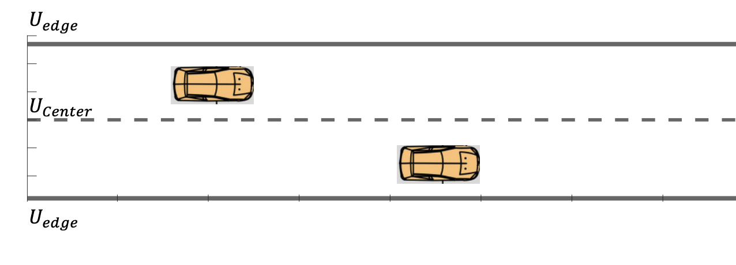

In this study, exponential functions of the lateral distance from the road edges are considered to formulate the road edge potential. The left and right edge potentials are defined as:

$$U_{edge_{l}}=k_{edge}\left(-e^{\left(y-y_{left}\right)} \right)$$

$$U_{edge_{r}}=k_{edge}\left(-e^{\left(y-y_{right}\right)} \right)$$

Here $k_{edge}$ is the parameter to adjust the magnitude of the repulsive potential of the road edge.

$y_{left}$ and $y_{right}$ are the left and right road boundary values.

Combining the two road edge potentials, the resulting overall potential is shown in the figure below.



Considering a gaussian function, the centerline potential can be formulated as,

$$U_{center}=K_{c}e^{-\frac{d^{2}}{2{}^{2}}}$$

Here $K_{c}$ is the coefficient of the road centerline, $d$ is the distance from the ego vehicle to the road centerline, $σ$ is the convergence coefficient of road width.

Combining the road edge potential and the centerline potential, we obtain the total road potential.

$$U_{road}={(U}_{edge_{l}}+U_{edge_{r}})+U_{center}$$

For $K_{c}=35, σ=1$ the total road potential field is shown in the figure below.



The top view of the road potential is shown below:



For different values of $K_{c}$, the centerline potential is changed as shown in the figures below:



Increasing the coefficient of road centerline increases the centerline potential. A right choice of $K_{c}$ is required to formulate the overall road potential to follow the lane and do lane changes if necessary.

#### Obstacle Potential $(U_{obstacle})$:

The potential field of an obstacle vehicle is a repulsive potential field which keeps the ego vehicle at a safe distance from the obstacle. The obstacle potential is formulated in a way such that the ego vehicle maintains a safe distance by either following the vehicle or changing its current lane to the other.

A two-dimensional Gaussian distribution approach is used to model the obstacle potential since it allows to model the repulsive force of an obstacle vehicle as a smooth and continuous function, rather than a sharp potential barrier. This can make it easier for the ego vehicle to navigate around the obstacle vehicle and follow a smoother path.

The obstacle potential defines the behavior of the ego vehicle when it approaches the obstacle vehicle. In this study, the obstacle potential incorporates the safety by taking the following factors into effect:

1. The friction coefficient between the ego vehicle and the road surface for safe lane changes.
2. The size of the obstacle vehicle
3. The velocity of the ego vehicle.

To start with, a simple two-dimensional gaussian distribution function based on only obstacle vehicle’s position is expressed as:

$$U=k_{veh}e^{\left\{-\frac{{\left(x-x_{veh}\right)}^{2}}{σ_{x}^{2}}+\frac{{\left(y-y_{veh}\right)}^{2}}{σ_{y}^{2}}\right\}}$$

Here $k_{veh}$ is the weight factor for the potential function of the obstacle vehicle which defines the peak value of potential.





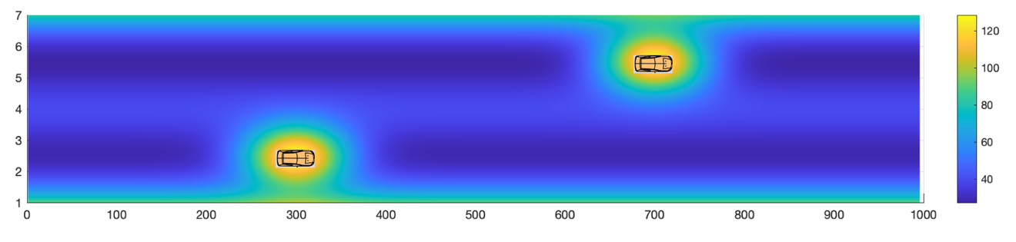

obstacle+road potential, sx=60

1. Friction coefficient between the road and the ego vehicle ($μ)$:



$$U=k_{veh}e^{\left\{-\frac{{\left(x-x_{veh}\right)}^{2}}{σ_{x}^{2}}+\frac{{\left(y-y_{veh}\right)}^{2}}{σ_{y}^{2}}+C_{1}(1-)\frac{{\left(x-x_{veh}\right)}^{2}}{σ_{x}^{2}}\right\}}$$

1. Vehicle repulsion potential based on friction coefficient and mass of the vehicle.

The traditional APF considers only the relative position to keep the ego vehicle away to realize the collision avoidance. In this research, to keep the ego vehicle at a relatively safer distance, the obstacle vehicle repulsion is formulated incorporating the effects of road friction and mass of the obstacle vehicle.

The vehicle obstacle potential along the longitudinal direction (parallel to the lane) is increased with decrease in friction coefficient for the ego vehicle to follow a larger safe distance. The following distance can be decreased if the road surface is rough (higher friction).

The following distance is also increased if the obstacle vehicle has a higher mass.

To incorporate this friction effect in the obstacle potential, the convergence coefficient along the X-direction is modified.



$$U=k_{veh}e^{\left\{-\frac{{\left(x-x_{veh}\right)}^{2}}{σ_{x}^{2}}+\frac{{\left(y-y_{veh}\right)}^{2}}{σ_{y}^{2}} +{ (C}_{1}\left(1-\right)+C_{2}(M_{veh})) \frac{{\left(x-x_{veh}\right)}^{2}}{σ_{x}^{2}}\right\}}$$

$$U=k_{veh}e^{\left\{-\frac{{\left(x-x_{veh}\right)}^{2}}{\frac{σ_{x}^{2}}{1-C_{1}\left(1-\right)-C_{2}\left(M_{veh}\right)}} + \frac{{\left(y-y_{veh}\right)}^{2}}{σ_{y}^{2}}\right\}}$$

The vehicle potential in the lateral direction of the vehicle motion also plays an important role in deciding whether the ego vehicle must perform a lane change in the presence of lower friction surfaces. Hence the convergence coefficient along the lateral direction ( $σ_{y})$ can be modified by incorporating the effect of friction coefficient. This increase in vehicle potential along the lateral direction helps to attain a local minimum behind the obstacle vehicle rather than the other lane, which helps the ego vehicle to follow the obstacle vehicle at a safe distance.







$$U=k_{veh}e^{\left\{-\frac{{\left(x-x_{veh}\right)}^{2}}{\frac{σ_{x}^{2}}{1-C_{1}\left(1-\right)-C_{2}\left(M_{veh}\right)}} + \frac{{\left(y-y_{veh}\right)}^{2}}{\frac{σ_{y}^{2}}{1-C_{3}(1-μ)}}\right\}}$$

The vehicle obstacle potential field (static) combined with the road and the target potential can be visualized as shown in the figure below:



## Gradient Descent for Path Planning

Gradient descent is a commonly used optimization algorithm that is used to minimize a function by iteratively adjusting the parameters in the direction of the steepest descent of the function. It is a first-order iterative optimization algorithm. Gradient descent can be used in APF for path planning by computing the gradient of the potential function and moving the ego vehicle in the direction of the negative gradient. The gradient represents the direction of the steepest descent or the direction in which the potential function decreases the fastest. The following steps are applied to apply gradient descent in APF for path planning:

1. Define objective function: The first step in gradient descent is to define an objective function to minimize. The total potential field is the objective function in our research. Once this is defined, the next step is to initialize the parameters of the model. The parameters are the variables that the algorithm will adjust to minimize the objective function.
2. Gradient Computation: The gradient of the potential function represents the direction in which the ego vehicle should move. The gradient gives the direction of steepest ascent, so multiplying it by -1 results in the direction of steepest descent. The gradient can be computed analytically or numerically using finite differences.
3. Way point update: After the gradient computation, the next waypoints are updated by subtracting the product of the learning rate and the gradient of the current value of the potential function. The learning rate is a hyperparameter that controls the step size of the algorithm. If the learning rate is too small, the algorithm may converge too slowly, while if it is too large, the algorithm may overshoot the minimum.

|  |  |
| --- | --- |
|  |  |

## APF tuning process for path planning

* 1. Straight road with no obstacle vehicles
  2. Straight road with one obstacle vehicle – Stuck in local minima.

|  |  |
| --- | --- |
|  |  |

* 1. Straight road with one obstacle vehicle – Very low obstacle potential field

|  |  |
| --- | --- |
|  |  |

* 1. Straight road with one obstacle vehicle – Low obstacle potential and centerline potential

|  |  |
| --- | --- |
|  |  |

* 1. Straight road with one obstacle vehicle – Planned final path.

|  |  |
| --- | --- |
|  |  |

## Vehicle Dynamics and Control

## Overall architecture

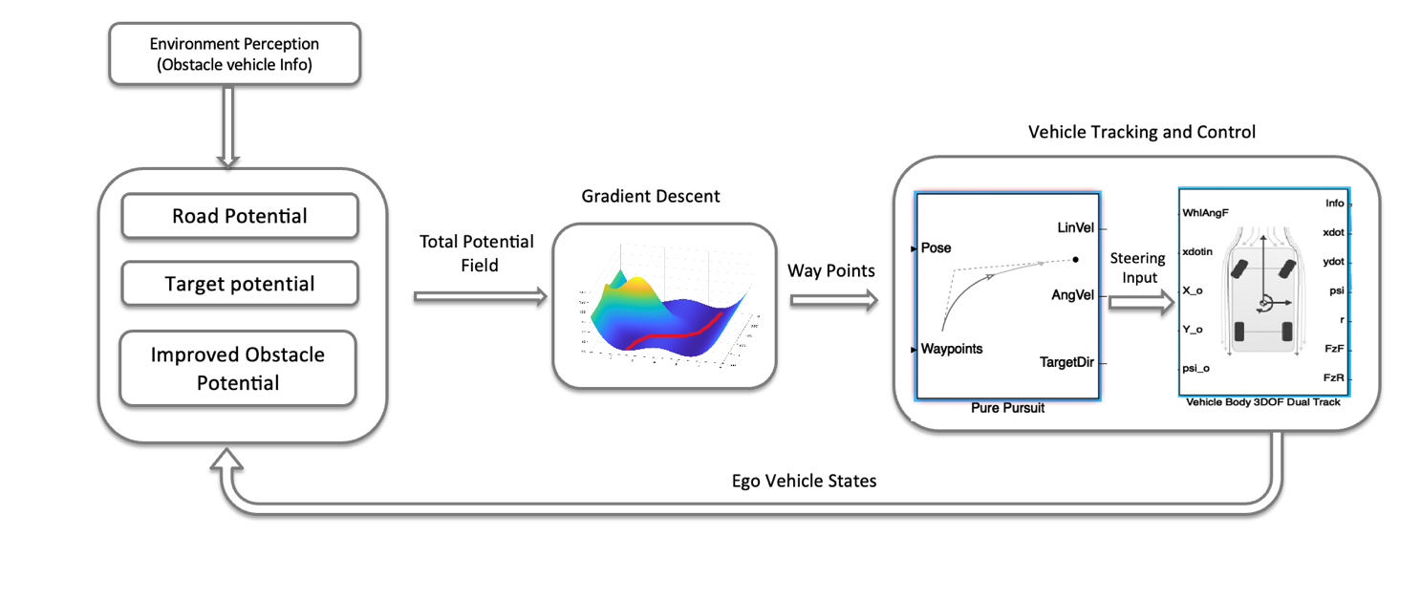

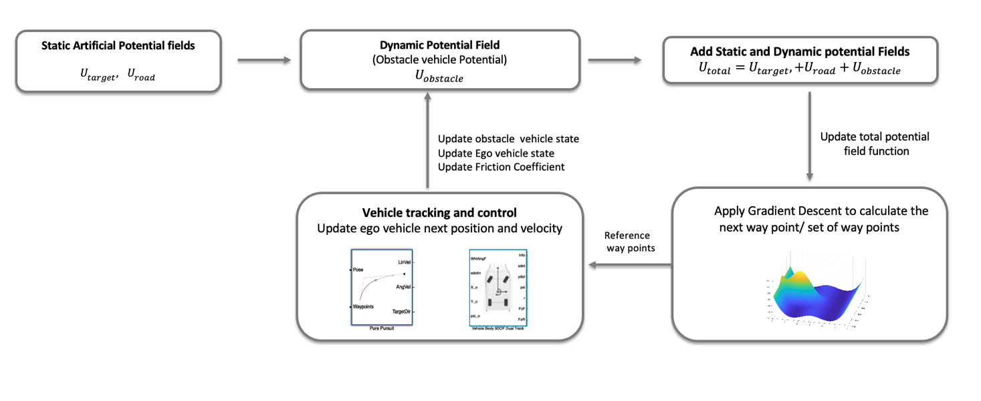

## Results and Discussion

Scenario 1: Low Road Risk ( $μ=0.7)$ and Light-Duty lead vehicle







Scenario 2: Low Road Risk ( $μ=0.7)$ and Heavy-Duty lead Vehicle







Scenario 3: Medium Road Risk ( $μ=0.5)$ and Light-Duty lead vehicle





Scenario 4: Medium Road Risk ( $μ=0.5)$ and Heavy-Duty lead vehicle







Scenario 5: High Road Risk ( $μ=0.3)$ and Light-Duty lead vehicle





Scenario 6: High Road Risk ( $μ=0.3)$ and Heavy-Duty lead vehicle



# Chapter 5. Verification and Validation

## Diagram Description automatically generatedOverview

## ImageModel in loop V&V

## Diagram Description automatically generatedHardware in loop V&V

# Bibliography

|  |  |
| --- | --- |
| [1] | "W. Jansen, “Lateral path-following control for automated vehicle platoons,” MSc Thesis, Delft University of Technology, 2016.". |
| [2] | "G. M. Hoffmann, C. J. Tomlin, M. Montemerlo, and S. Thrun, “Autonomous automobile trajectory tracking for off-road driving: Controller design, experimental validation and racing,” American Control Conference, vol. 1-13, p. 3910, 2007.". |
| [3] | "Z. Huang, Q. Wu, J. Ma, and S. Fan, “An APF and MPC combined collaborative driving controller using vehicular communication technologies,” Chaos, Solitons and Fractals, vol. 89, pp. 232–242, 2015.". |
| [4] | "S. Magdici and M. Althoff, “Fail-safe motion planning of autonomous vehicles,” Interna- tional Conference on Intelligent Transportation Systems, pp. 452–458, 2016.". |
| [5] | " New Atlas, “Self-driving vehicles: What are the six levels of autonomy?,” https://newatlas.com/sae-autonomous-levels-definition-self-driving/49947/, 2017.". |
| [6] | "Piao, J., Li, Z., & Li, K. (2020). Perception System of Autonomous Vehicles: A Comprehensive Review. IEEE Access, 8, 103239-103256.". |
| [7] | "Wang, C., & Zhao, X. (2019). Object Detection for Autonomous Vehicles: A Survey. IEEE Transactions on Intelligent Transportation Systems, 20(10), 3534-3548.". |
| [8] | "Gehrig, D., & Lauer, T. (2019). Sensor Fusion for Autonomous Vehicles: A Review of State-of-the-Art Algorithms. IEEE Sensors Journal, 19(17), 7370-7388.". |
| [9] | "Maurer, M., Gerdes, J. C., Lenz, B., & Winner, H. (2016). Autonomous Driving: Technical, Legal and Social Aspects. Berlin: Springer.". |
| [10] | "Urmson, C., Anhalt, J., Bagnell, D., Baker, C., Bittner, R., et al. (2008). Autonomous driving in urban environments: Boss and the Urban Challenge. Journal of Field Robotics, 25, 425-466.". |
| [11] | "Leonard, J., How, J., Teller, S., Berger, M., Campbell, S., et al. (2008). A perception-driven autonomous urban vehicle. Journal of Field Robotics, 25, 727-74.". |
| [12] | "Furgale, P., Schwesinger, U., Rufli, M., Derendarz, W., Grimmett, H., et al. (2013). Toward automated driving in cities using close-to-market sensors: an overview of the V-Charge Project. In 2013 IEEE Intelligent Vehicles Symposium (IV) (pp. 809-816). New". |
| [13] | "Ulbrich, S., Reschka, A., Rieken, J., Ernst, S., Bagschik, G., et al. (2017). Towards a functional system architecture for automated vehicles. arXiv:1703.08557.". |
| [14] | "E. W. Dijkstra, “A note on two problems in connexion with graphs,” Numerische mathematik, vol. 1, pp. 269–271, 1959.". |
| [15] | "Kavraki, L. E., Svestka, P., Latombe, J. C., & Overmars, M. H. (1996). Probabilistic roadmaps for path planning in high-dimensional configuration spaces. International Journal of Robotics Research, 15(6), 529-549.". |
| [16] | "LaValle, S. M. (1998). Rapidly-exploring random trees: A new tool for path planning. Technical Report, Computer Science Department, Iowa State University.". |
| [17] | "Khosravi, H., & Vossoughi, G. (2011). A review of artificial potential field methods as a classical approach in robot path planning. Journal of Applied Sciences, 11(9), 1637-1645.". |
| [18] | "Kurt, A., & Özgüner, Ü. (2004). Hierarchical finite state machines for autonomous mobile systems. Robotics and Autonomous Systems, 47(2-3), 91-103.". |
| [19] | "Havlak, F., & Campbell, M. (2014). Discrete and continuous, probabilistic anticipation for autonomous robots in urban environments. Transactions on Robotics, 30, 461-474.". |
| [20] | "Tran, Q., & Firl, J. (2013). Modelling of traffic situations at urban intersections with probabilistic non-parametric regression. In Intelligent Vehicles Symposium (IV), 2013 IEEE (pp. 334-339). IEEE.". |
| [21] | "Ulbrich, S., & Maurer, M. (2013). Probabilistic online POMDP decision making for lane changes in fully automated driving. In 16th International Conference on Intelligent Transportation Systems (pp. 2063-2067). IEEE.". |
| [22] | "Brechtel, S., Gindele, T., & Dillmann, R. (2014). Probabilistic decision making under uncertainty for autonomous driving using continuous POMDPs. In 17th International Conference on Intelligent Transportation Systems (pp. 392-399). IEEE.". |
| [23] | "Bandyopadhyay, T., Won, K. S., Frazzoli, E., Hsu, D., Lee, W. S., & Rus, D. (2013). Intention-aware motion planning. In Algorithmic Foundations of Robotics X (pp. 475-491). Springer.". |
| [24] | "Wu, X., Nayak, A., and Eskandarian, A., "Motion Planning of Autonomous Vehicles under Dynamic Traffic Environment in Intersections Using Probabilistic Rapidly Exploring Random Tree," SAE Intl. J CAV 4(4):383-399, 2021". |
| [25] | "León, A., Millán, J. D., & Pérez, J. (2018). Probabilistic roadmap-based motion planning for autonomous driving using occupancy grid maps. Journal of Intelligent & Robotic Systems, 91(1), 119-137.". |
| [26] | "Chen, X., Cai, Y., & Wang, K. (2021). Efficient motion planning for autonomous driving using multi-objective optimization. IEEE Transactions on Intelligent Transportation Systems, 22(7), 4142-4152.". |
| [27] | "Z. Bai, B. Cai, W. ShangGuan and L. Chai, "Deep Learning Based Motion Planning For Autonomous Vehicle Using Spatiotemporal LSTM Network," 2018 Chinese Automation Congress (CAC), Xi'an, China, 2018, pp. 1610-1614, doi: 10.1109/CAC.2018.8623233.". |
| [28] | "D. Li, Y. Wu, B. Bai and Q. Hao, "Behavior and Interaction-aware Motion Planning for Autonomous Driving Vehicles based on Hierarchical Intention and Motion Prediction," 2020 IEEE 23rd International Conference on Intelligent Transportation Systems (ITSC),". |
| [29] | "Goodwin, L.; Pisano, P. Weather-responsive traffic signal control. ITE J. 2004, 74, 28–33.". |
| [30] | "Highway Statistics Publications. Available online: https://www.fhwa.dot.gov/policy/ohpi/hss/hsspubs.cfm". |
| [31] | "Arvidsson, A.K. The Winter Model—A new way to calculate socio-economic costs depending on winter maintenance strategy. Cold Reg. Sci. Technol. 2017, 136, 30–36.". |
| [32] | "Shi, X.; Fu, L. Sustainable Winter Road Operations, 1st ed.; Wiley Blackwell: Hoboken, NJ, USA, 2018.". |
| [33] | "Kangas, M., Heikinheimo, M., & Hippi, M. (2015). RoadSurf: A modelling system for predicting road weather and road surface conditions. Meteorological Applications, 22(3), 544-553.". |
| [34] | "Tarleton, J. (2015). Critical conditions—The weather plays a vital role in road safety and traffic management applications. Intertraffic World Annual Showcase 2015. Traffic Management, 108-109.". |
| [35] | "Nowrin, T., & Kwon, T. J. (2022). Forecasting short-term road surface temperatures considering forecasting horizon and geographical attributes—An ANN-based approach. Cold Regions Science and Technology, 202, 103631.". |
| [36] | "Ding X, Kwon TJ. Winter Road Friction Estimations via Multi-Source Road Weather Data—A Case Study of Alberta, Canada. Future Transportation. 2022; 2(4):970-987. https://doi.org/10.3390/futuretransp2040054". |
| [37] | "N. H. Amer, H. Zamzuri, K. Hudha, and Z. A. Kadir, “Modelling and control strategies in path tracking control for autonomous ground vehicles: A review of state of the art and challenges,” Journal of Intelligent and Robotic Systems: Theory and Applications". |
| [38] | "Arvidsson, A. K. (2017). The Winter Model—A new way to calculate socio-economic costs depending on winter maintenance strategy. Cold Reg. Sci. Technol., 136, 30-36.". |